USER GUIDE

Courier Management System

|  |  |
| --- | --- |
| Student1448726 | MUHAMMAD YASHAL MINHAS |

Group Members

* Semester : 2 (CPISM)
* Batch Code : 2301g3
* Faculty :Owais Imam

ADMIN VIEW

LOG IN

* Admin Has To Sign in Here By Details (Email And Password)
* AlsoCan Be Logout

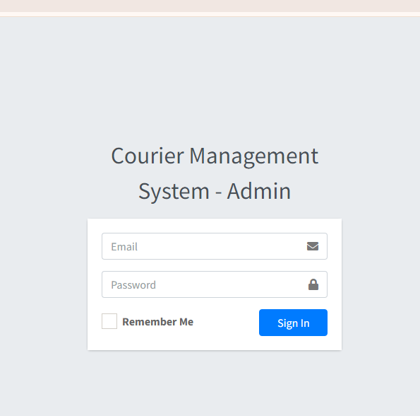

DASHBOARD

* Admin Can See Every Short Details Of Branch, Branch Staff And Parcel In “DASHBOARD”
* Full Screen Button
* Admin User Name Also Show’s At The Right Top
* Side Bar Can Be View In Image

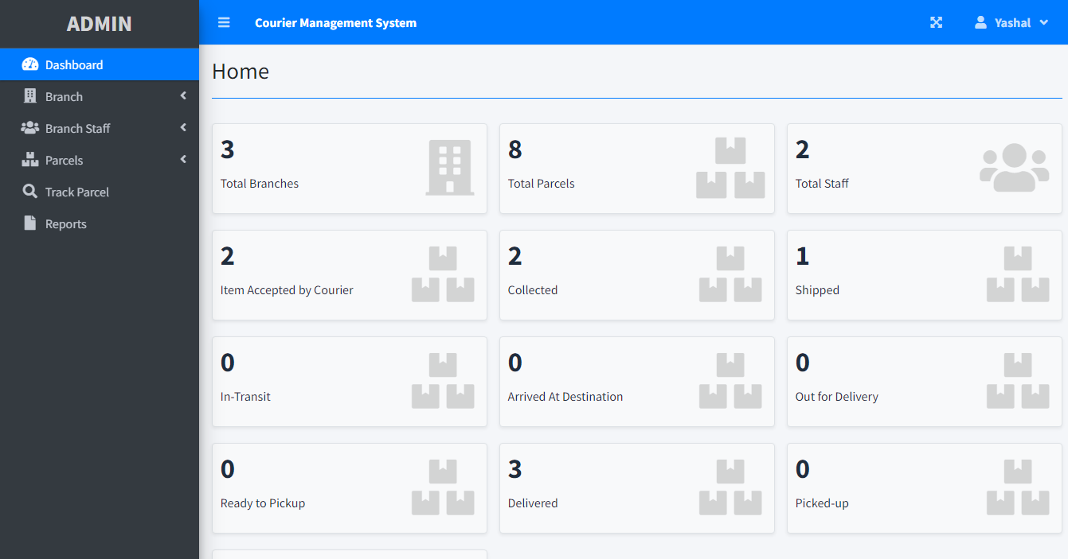

Branch

Add New

* Admin Can Add New Branch’s
* Admin Need To Fill The Address In Order To Create “New Branch”

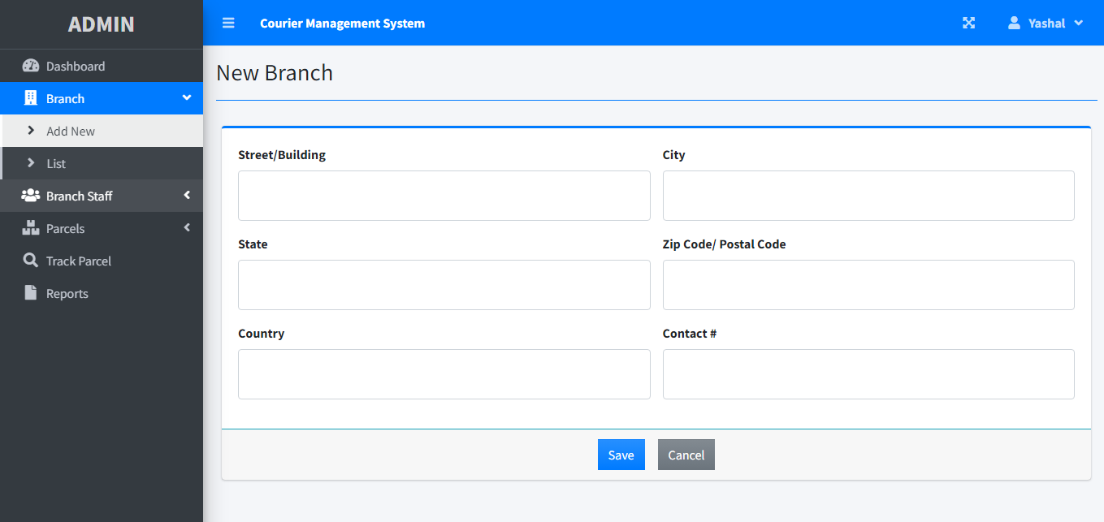

Branch

List

* Admin Can View All Exist Branch
* Branch Can be Edit Or Remove

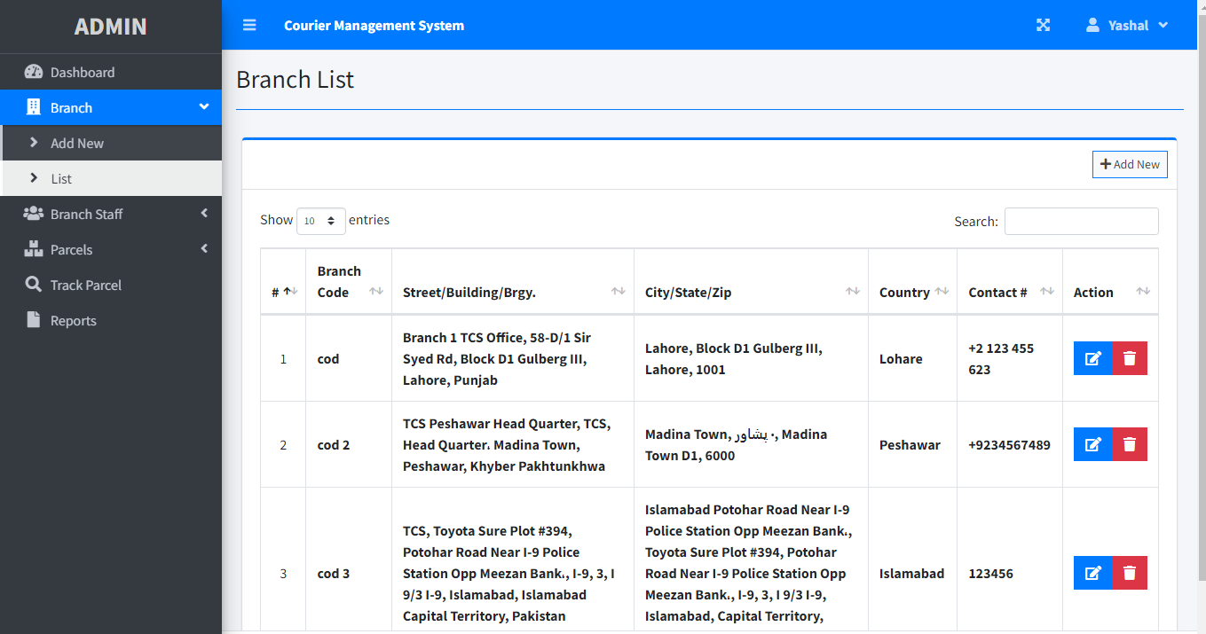

Branch staff

Add New

* Admin Can Add New Branch Staff
* Admin Need To Fill The Identity Of Staff In Order To Create “New Staff”
* Different Branches Name Can Be Add In “New Staff”

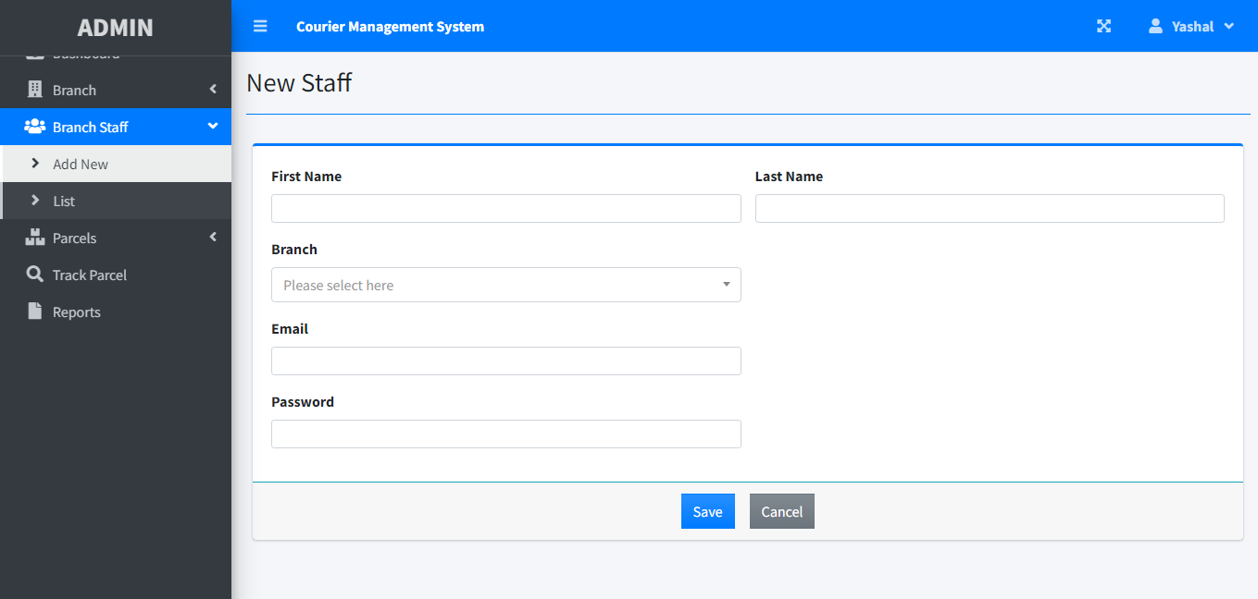

Branch staff

List

* Admin Can View All Branch Staff
* Branch Staff Can be Edit Or Remove

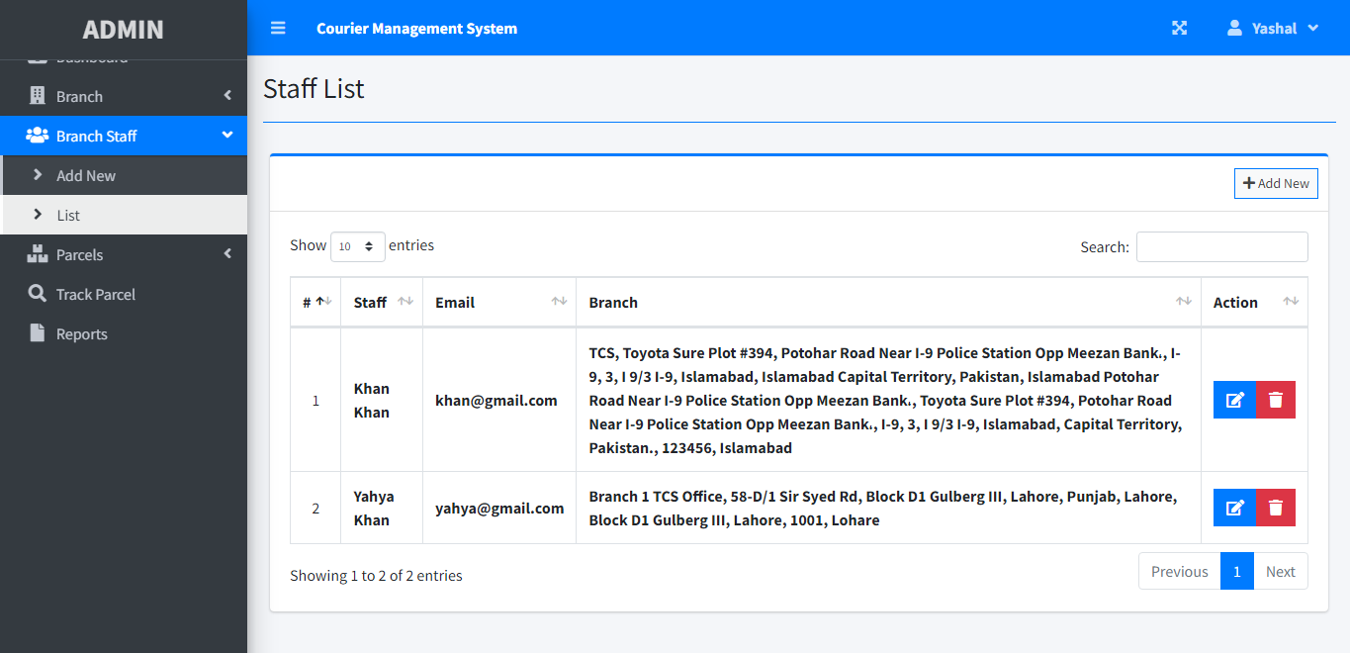

Parcel

Add New

* Admin & Branch Staff Can Add New Parcel
* Admin & Branch Staff Need To Fill The Information Of Parcel In Order To Create “New Parcel”
* Type Of Parcel (Pickup, Delivery) Can Be Selected

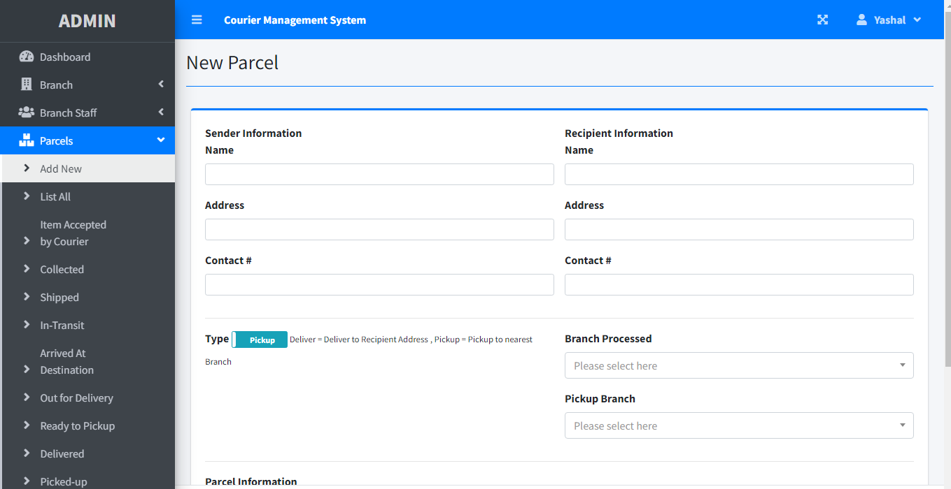

parcel

List All

* Admin & Staff Can View All Parcel In “Parcel List”
* Search To Find Specific Parcel
* Parcel Can be Edit Or Remove
* Status Of Parcel Can Be View

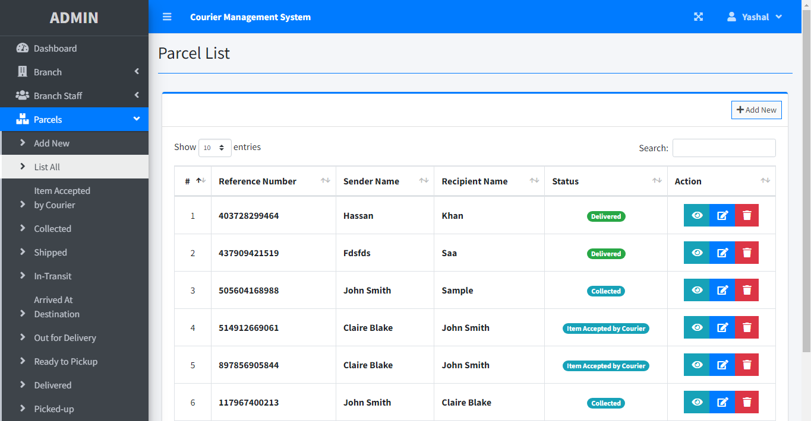

parcel

Item Accepter By Courier

* Admin & Staff Can View All Parcel That Are In “Item Accepted By Courier”

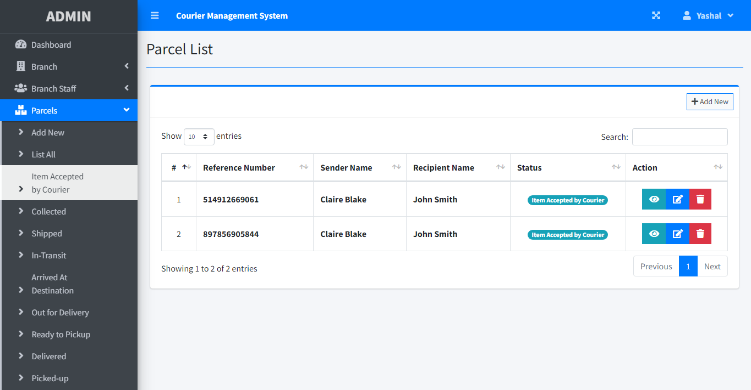

parcel

Collected

* Admin & Staff Can View All Parcel That Are Collected By Customer In “Collected”

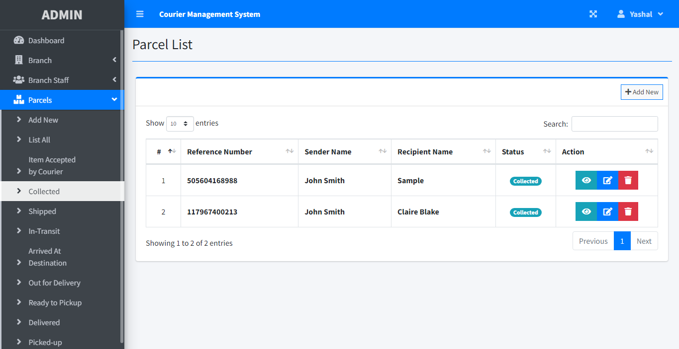

parcel

Shipped

* Admin & Staff Can View All Parcel That Are Shipped In “Shipped”

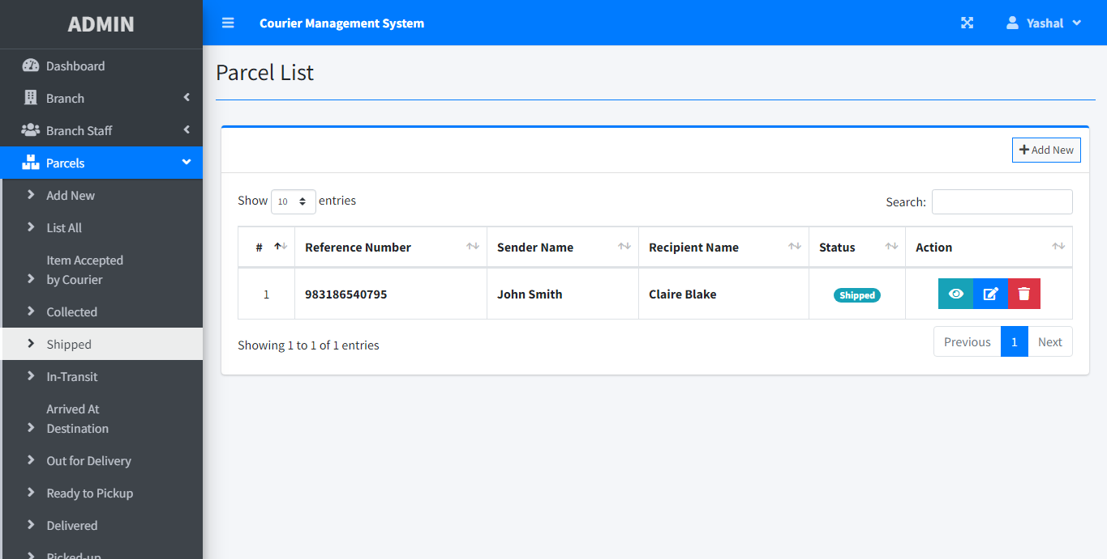

parcel

In Transit

* Admin & Staff Can View All Parcel That Are In-Transit In “In-Transit”

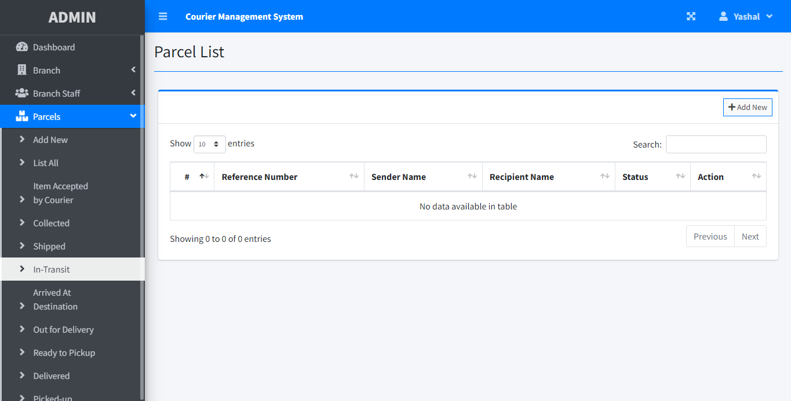

parcel

Arrived At Destination

* Admin & Staff Can View All Parcel That Are Arrived At Destination In “Arrived At Destination”

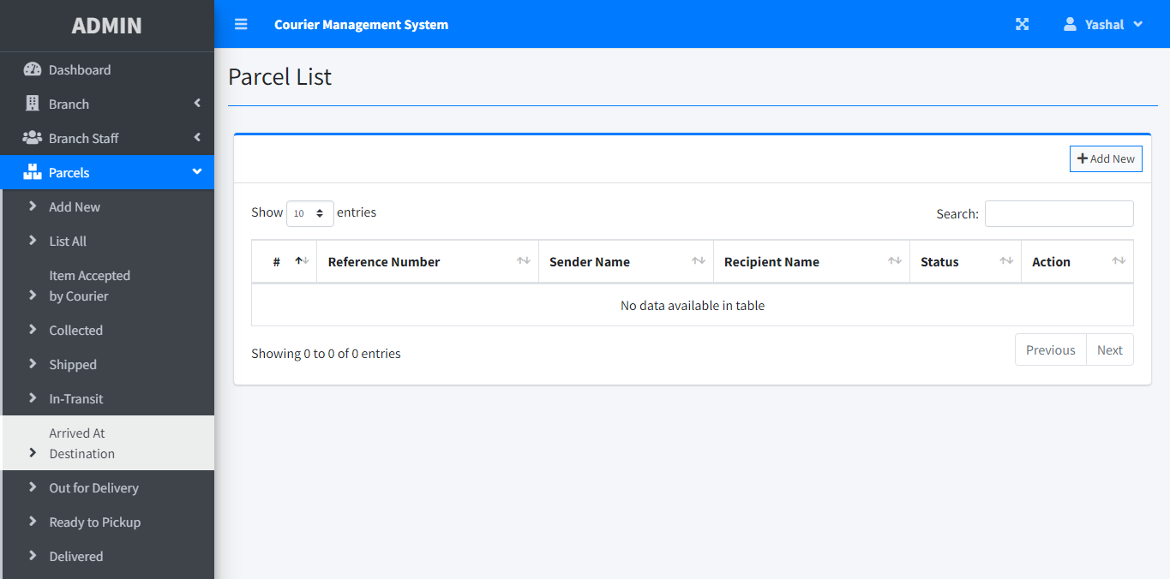

parcel

Out Of Delivery

* Admin & Staff Can View All Parcel That Are Out Of Delivery In “Out Of Delivery”

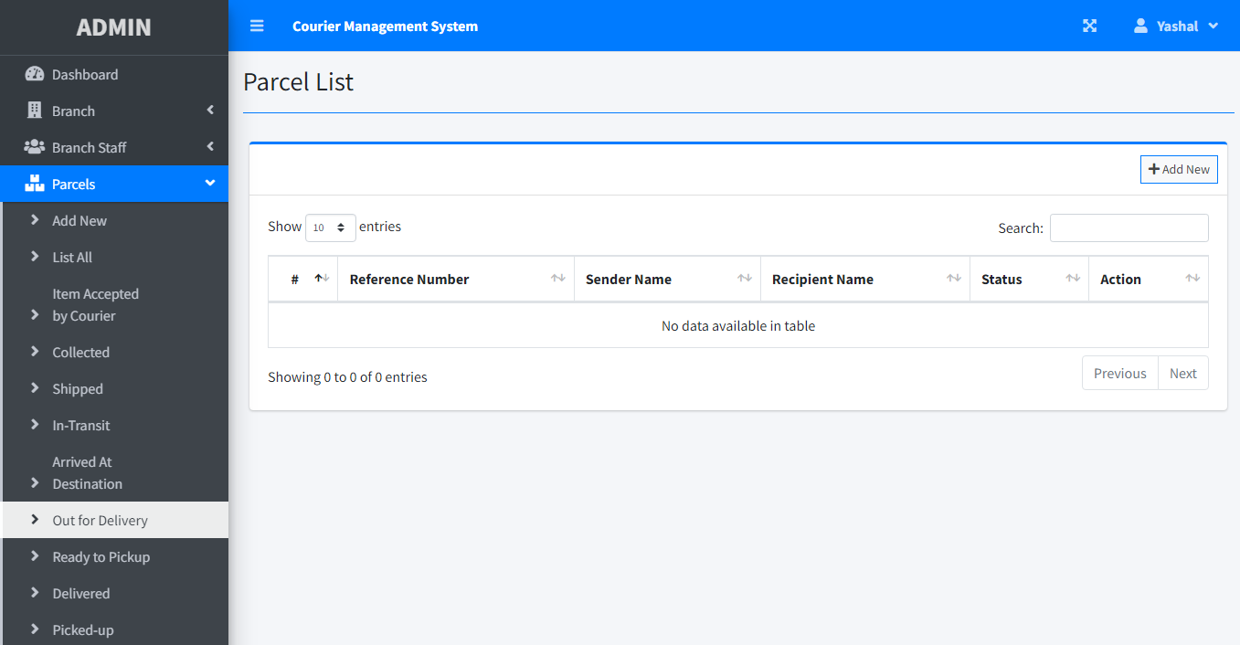

parcel

Ready To Pick Up

* Admin & Staff Can View All Parcel That Ready To Pickup In “Ready To Pickup”

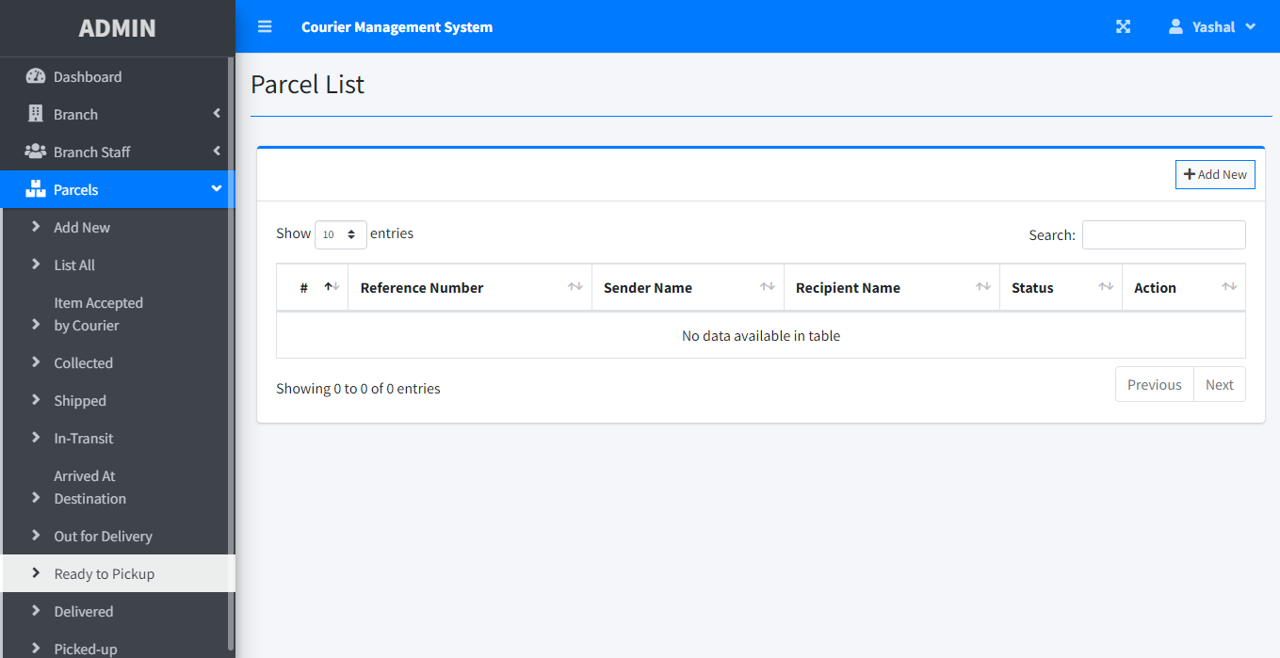

parcel

Delivered

* Admin & Staff Can View All Parcel That Are Delivered In “Delivered”

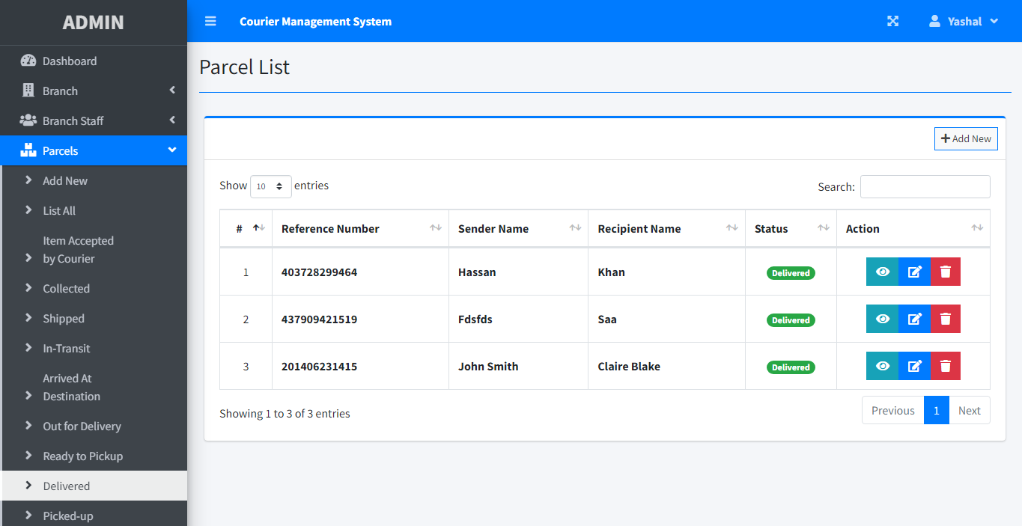

parcel

Picked Up

* Admin & Staff Can View All Parcel That Are Picked-Up In “Picked-Up”

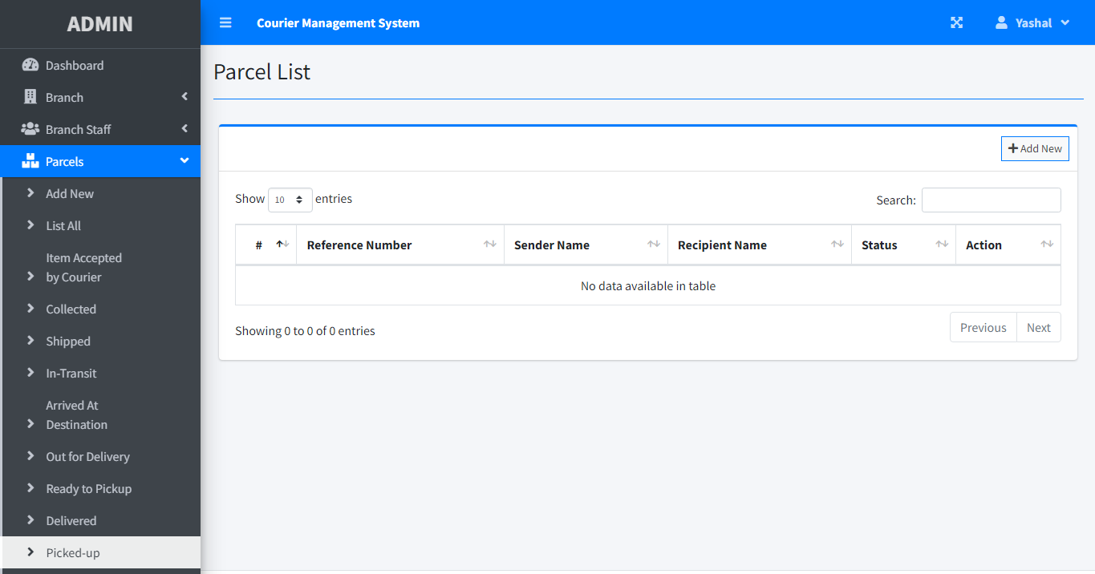

track

Tracking

* Admin & Staff Can Tracking All Parcel To View All Status Bar That Are In “Track”
* Parcel Number Must Be Needed

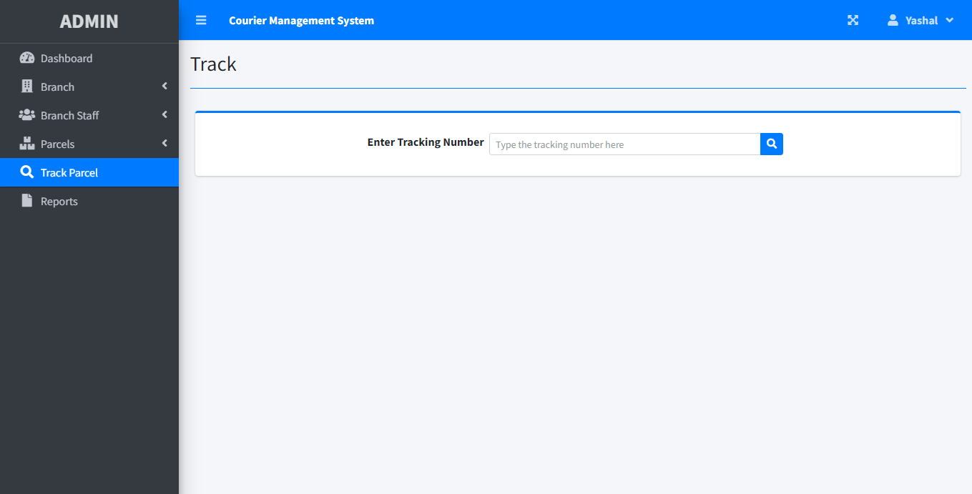

Reports

* Admin & Staff Can View All Parcel Reports That Are In “Reports”
* Reports Can Check By Date (From ,TO) Or Status

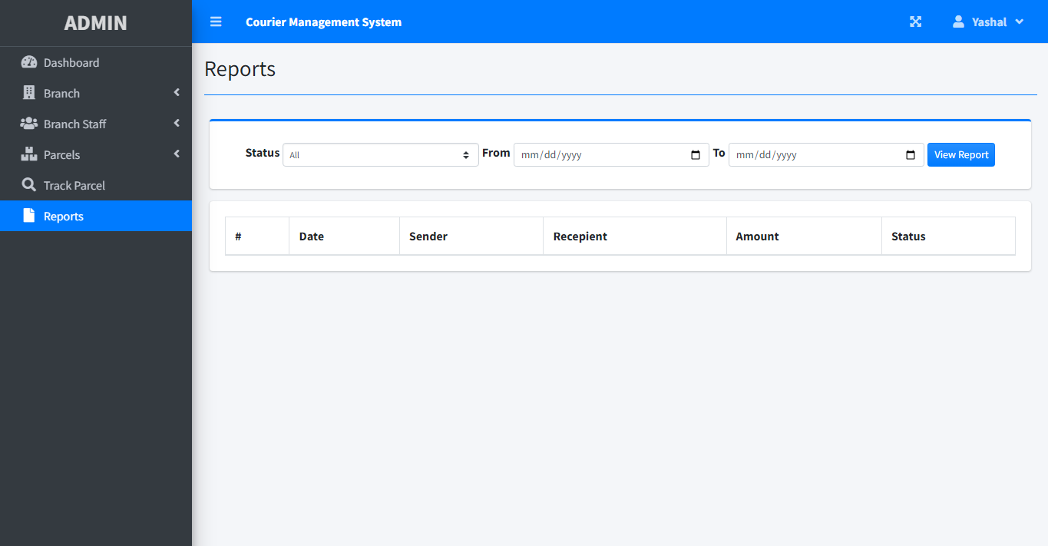

USER VIEW

Login

* User Can Create An Account
* Need Details To Log In

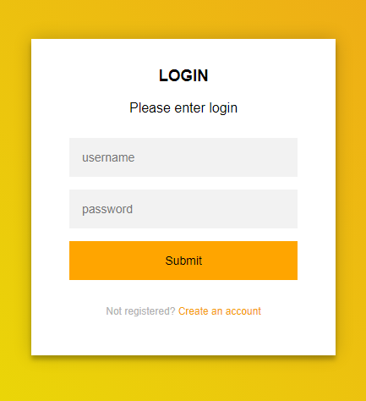

user

Home

* This Is One Page Website
* Nav Bar Is Added
* User Can Log Out
* Search To Find Something :>
* Home



user

Messege

* This Is Message Box Just for Show

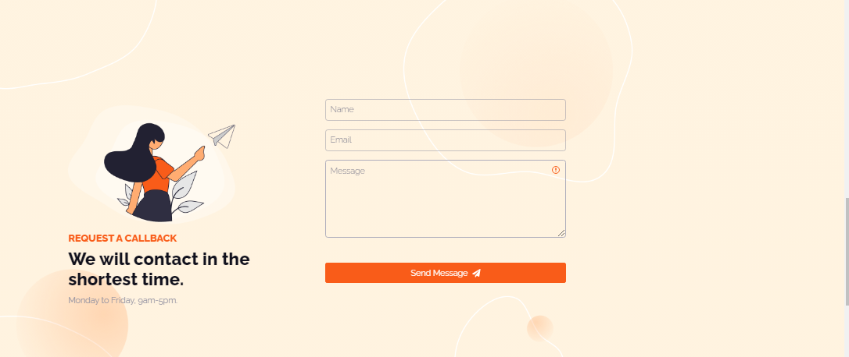

user

Our Reviews

* This Is Our Review Page
* Here Is Some 5Star Review From Clients



user

Video

* This Is Video Of Our Brand On YouTube





user

Footer & Tracking

